An analysis of discussions on topics related to Automation on different subreddits.

What are the talking points that the general public use on automation, and what is the consensus on it?

Rohit Rokde  
 Luddy School of Informatics, Computing, and Engineering  
 Indiana University, Bloomington, United States of America  
 [rrokde@iu.com](mailto:rrokde@iu.com)

Introduction

Reddit is an American social news sharing and discussion website. Registered users on this site write content, and share links and images which are then voted up or down [1] by other registered users. The format of the website is such that the site is divided into categories called “subreddits”. Each subreddit is created for a specific topic for discussion or social news. Examples of the topics are news, science, politics, food, movies, computer games, etc. The content on these subreddits is sorted based on the number of “upvotes” or “downvotes” such that a post or a comment with the most number of upvotes is shown to the users first.

Reddit was started by two roommates, Steve Huffman and Alexis Ohanian, at University of Virginia in 2005 and was originally written in Common Lisp but was eventually rewritten in Python in December 2005 for wider access to code libraries and greater development flexibility [1]. The team expanded to include Christopher Slowe, an American businessman, and Aaron Swartz (founder of a company named Infogami), and merged into a new company called Not a bug. The company was then acquired by different corporations and changed its name several times since its start. Amid a lot of changes in its user interface, the main theme of Reddit remained the same, that is, the users dictated the nature of the discussions/posts and the popularity of the discussions/posts. Only in the case of violation of the website’s policies, content is removed from the subreddit by so-called “moderators” of that particular subreddit.

Background

Automation is the technology by which a process or procedure is performed with minimal human assistance[2]. Throughout history automation has been of two forms, mechanical and electrical. During the industrial revolution, the use of grain mills, oils pumps, furnaces, steam engine, etc were fitted with temperature and pressure regulators. After the invention of transistor in the 20th century, relay logic gained popularity among engineers and transformed the industries across the western world and the globe.

Perhaps the most cited advantage of automation in industry is that it is associated with faster production and cheaper labor costs[2]. Although its primary effects are beneficial for an industry and society, its secondary effects may not be beneficial to the society. One of the disadvantages of automation is the high initial costs and the displacement of workers in favor of machines. Although historically, the effect of displacement of workers due to automation (also called a Mechanization in the past) was acknowledged and well taken care of [3], the new age automation present an all together different challenge.

Until now most of the automation replaced humans tasked with mechanical aspects of work. Production, assembling distribution and many such similar aspects have been automated since the past. The workers displaced from these jobs were later trained to do jobs requiring cognitive abilities unrealizable by any machine. But since the recent advancements in Artificial Intelligence (AI) and Machine Learning (often referred as a sub-branch of AI), machines can now be trained to do specific jobs that equate or outperform the achievable efficiencies of an average human being. The World Bank's World Development Report 2019 mentions the fact that the nature of work is going to change in the coming future, and that governments have an important role to provide enhanced social protection to all its citizens irrespective of the terms on which they work [4].

Methods and Data

A total of five subreddits were selected for the purpose of collecting the required data. The data from the first two subreddits was collected using the “top” function of PRAW (Python Reddit API Wrapper) library. For the rest of the subreddits, we used the function call “search” and passed a parameter called “automation”. For the both the function calls, an additional parameter – “limit=1000” was used to fetch maximum possible data points.

The five subreddits are given as follows:

1. Automate
2. automation
3. DarkFuturology
4. Economics
5. Libertarian

The above subreddits were selected for their high popularity among the users. Particularly, the high number of users registered to those subreddits and their relevance to our topic. Also the data points collected from the subreddits consisted of following fields:

1. Title (of the posts): Python strings stored in python lists
2. Comments (from each of the posts): Python strings stored in python lists
3. Post ID (to map comment data to the “post” data): Python strings stored in python lists

After the data was collected we tokenized the words using the NLTK (Natural Language Toolkit) library, removed the stopwords, and then finally normalized the words using regular expressions package in Python.

**Analysis**

Two types of analysis were performed on data collected from each of the subreddits viz.

1. WordCloud generation
2. Topic modelling using LDA

Following are the word clouds from the data that was collected from the text present in the “comments”.

**Automate**

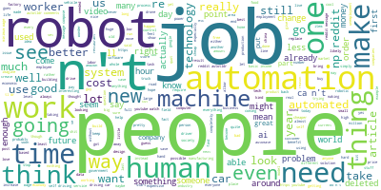

**automation**

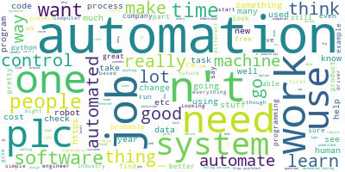

**DarkFuturology**

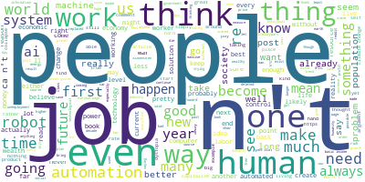

**Economics**

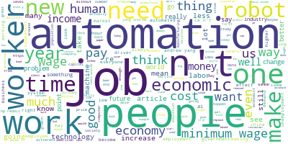

**Libertarian**

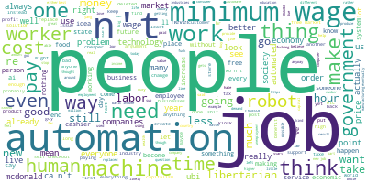

The total number of tokens used for forming these word clouds are given in the following table:

|  |  |
| --- | --- |
| Automate | 115216 |
| automation | 21419 |
| DarkFuturology | 18583 |
| Economics | 75196 |
| Libertarian | 82036 |

**Topic modeling report from subreddit “Automate”**

|  |  |
| --- | --- |
| Topic #0: | **people** make robots robot new way things machine humans automate |
| Topic #1: | like **jobs** automation time job https thing want car ai |
| Topic #2: | http work need automated human years technology self driving use |
| Topic #3: | think going good lot better com www know machines article |
| Topic #4: | reddit com comments really workers np ll cars ve ca |

**Topic modeling report from subreddit “automation”**

|  |  |
| --- | --- |
| Topic #0: | https time air automate lot going used test able human |
| Topic #1: | com **people** software want job learn programming using www free |
| Topic #2: | like **jobs** good way things better cost companies industrial different |
| Topic #3: | need know automated really data control process stuff new probably |
| Topic #4: | automation work plc use think make qainfotech code testing tools |

**Topic modeling report from subreddit “DarkFuturology”**

|  |  |
| --- | --- |
| Topic #0: | **people** time ai humans https climate population automated income ll |
| Topic #1: | like way world going new future long basic lot technology |
| Topic #2: | **jobs** automation human years things good society really ca ve |
| Topic #3: | work change thing actually life wealth want economic sure self |
| Topic #4: | think make need job robots know better money robot reality |

**Topic modeling report from subreddit “Economics”**

|  |  |
| --- | --- |
| Topic #0: | **jobs** **people** need article working industry ca demand problem tax |
| Topic #1: | wage think labor economy low technology higher better know economics |
| Topic #2: | minimum years https want unemployment year market ai world things |
| Topic #3: | automation work job like workers new make robots good way |
| Topic #4: | time income pay money going wages http human economic really |

**Topic modeling report from subreddit “Libertarian”**

|  |  |
| --- | --- |
| Topic #0: | think need pay 15 human automated technology food working business |
| Topic #1: | **people** wage new money time government workers want things years |
| Topic #2: | **jobs** going make cost libertarian hour better thing economy happen |
| Topic #3: | automation work labor market self use ca order cheaper making |
| Topic #4: | minimum like job machines way robots free really wages https |

**Discussion**

If we leave out the most common (and obvious) words from the word cloud such as “Automation”, “automate” and “automating”, we can see some common words that emerge from each of the subreddits that we have found across the board. For example, words like “people” and “jobs”. We can see these two words emerging out as the most used words from all the subreddits.

The reason for this is that the current discussion on the topic of Automation has moved (in a big way) towards its economic impact on the society. Clearly, the abundance of goods and services provided by the current onslaught of software and robotic automation has perhaps left many people jobless across the globe. Even though this always been the case since many decades of mechanization, the current trends with automation specifically, automation of jobs requiring (human) cognitive skills, creates an atmosphere of fear among the world citizens. We can see the notion of fearful expectations of the future from the comments given on some the reddit posts.

Here are some of the examples of the user comments from one of the subreddits

“*Self driving cars are going to be the real tipping point. When we no longer need truckers to get goods around and pilots to fly planes and cab drivers then there's going to be too many unemployed workers to ignore.*”

“*I think the jobs that are created will be better jobs but they’ll be 50 to 1 (1 created for every 50 lost).*”

“*A career that starts at $25/hour in an otherwise economically depressed region becomes automated pushing people into unemployment, out of the labour force, into minimum wage work, or out of their communities. Damn right there is outrage. The job sucked, but the alternatives are worse.”*

We have seen some research that provides evidence of automation causing greater displacement of labor force. Certain occupations which fall under the category of higher risk of automation have been declining at an annual rate of - 2.0-2.5% [5].

**Conclusion**

It is quite evident that the awareness about automation and it’s impact on society is on the rise since the past decades. Forums like reddit provide an excellent platform for its users to have discussion to provide exposure to all kinds of perspectives on the topic. The main talking points of the reddit users revolve around jobs, people and work. We also find that a major theme that emerges out of the discussions that users have general negative view about the economic impact of automation on the society, but a general positive view about the certain topics such as rising standards of living.

**References**

[1] <https://en.wikipedia.org/wiki/Reddit>

[2] <https://en.wikipedia.org/wiki/Automation>

[3] Technology of Postal Modernization, Page 7, 1967 <https://books.google.com/books?id=u_c1AAAAIAAJ&pg=PA444&lpg=PA444&dq=mechanization+in+20th+century+civil+society+news+papers&source=bl&ots=5ubSTKeYEx&sig=ACfU3U10BNmQiUwI-LwpKSN7RPh0jnJeDA&hl=en&ppis=_e&sa=X&ved=2ahUKEwjRntjQzazoAhWDPM0KHcgiB0YQ6AEwAXoECAwQAQ#v=onepage&q=mechanization&f=false>

[4] <https://www.worldbank.org/en/publication/wdr2019>

[5] Automation, Labor Markets, and Trade , by Alejandro Micco, 2018

Conference Name:ACM Woodstock conference

Conference Short Name:WOODSTOCK’18

Conference Location:El Paso, Texas USA

ISBN:978-1-4503-0000-0/18/06

Year:2018

Date:June

Copyright Year:2018

Copyright Statement:rightsretained

DOI:10.1145/1234567890

RRH: F. Surname et al.

Price:$15.00